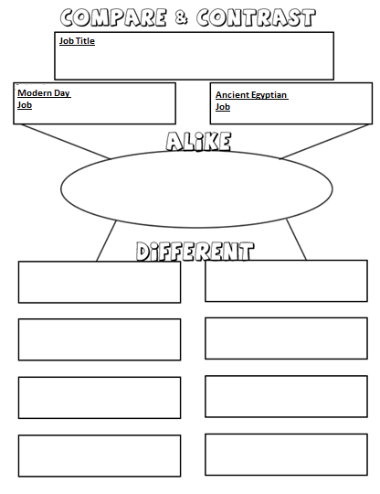
Tolkien:
How did Pharaohs compare?
Famous Pharaohs
You will need to research two Pharaohs and present your findings in a table like the one below. Choose two Pharaohs and contrast the similarities and differences in how they ruled and the changes that they made in Egyptian society. Copy the table below into your books to complete this task.
Pharaoh two
_____________________________
Pharaoh one
_____________________________

