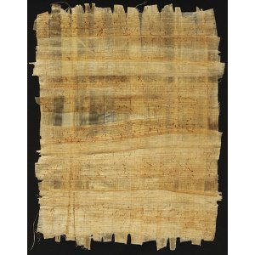
Papyrus – the paper of Ancient Egypt
Tolkien
For this task you will need:
- An iPad or a Computer to watch a movie clip

- Borrow a computer or iPad. See if anyone else in your group is doing this task and share a computer if you can.

- Open the movie file ‘How Ancient Egyptians made paper’ to watch a short clip a demonstration about how to make paper with papyrus. (http://www.youtube.com/watch?v=83JNvxFzkTY&feature=plcp )

- Undertake further research to make sure you have a deep understanding of the process used in Ancient Egyptian times.

- Your task is to write a procedural text about how to make paper from papyrus.

- Identify your audience – who will you be writing this text for?

- Don’t forget to include:
Remember: there will need to be enough detail for the reader to follow, but the writing needs to be concise.
  - A title
  - Introduction
  - Materials
  - Method
  - Pictures/diagrams

- Draft these instructions in your workbook. Proofread them and have a peer proofread them. (Offer to do this for another student in your group)

- Publish the procedural text in a creative way (your choice).

