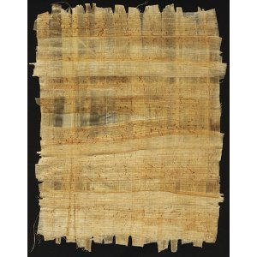
Papyrus – the paper of Ancient Egypt
Rodda and Meyers
For this task you will need:
- An iPad or a Computer to watch a movie clip

- Borrow a computer or iPad. See if anyone else in your group is doing this task and share a computer if you can.

- Open the movie file ‘How Ancient Egyptians made paper’ to watch a short clip a demonstration about how to make paper with papyrus. (http://www.youtube.com/watch?v=83JNvxFzkTY&feature=plcp )

- Write a procedural text (A set of detailed instructions) about how to make paper from papyrus. You should write the instructions for an audience who has never made paper before or seen it being made.

- Don’t forget to include:
  - A title
  - Introduction (briefly describe what these instructions are for)
  - Materials (items needed)
  - Method (step by step)
  - Images/diagrams (show the reader what you mean)

- Draft these instructions in your workbook. Proofread them and have a peer proofread them. (Offer to do this for someone in your group)

- Publish the procedural text in a creative way (your choice).

