Landmarks
Rodda and Meyers
Read me first!!!
What is a landmark?
A landmark includes anything that is easy to recognise, such as a building, mountain or river. The word landmark can also be used to describe places that might be of interest to tourists because of the special parts/features or the role it played in history. Landmarks can also be used to help us give someone directions, for example, “Drive over the large red bridge and then turn left”.
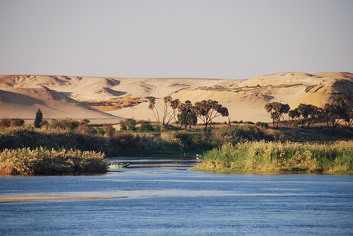
Natural landmark
These landmarks have occurred naturally. These include waterfalls, mountains, rock formations and rivers

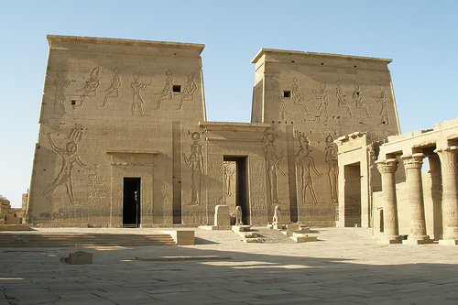
Man-made landmark
These landmarks have been built or created by humans. These include buildings, bridges and statues.

Landmarks Task – Rodda and Meyers
Your job is to create a 3D map of Ancient Egypt to help us tour around the country in the coming weeks!
You will need:
- A map template of Ancient Egypt or the map completed in the Geography workshop
- iPad or Laptop between two or a small group
- Scissors and Glue
- Colour pencils or textas
- On the map provided make sure that all of the BOLTSS are on the map. Remember Border, Orientation, Legend, Title, Scale and Source

- Using the Internet research the location of the following landmarks in Ancient Egypt. Mark the landmarks onto your map.

Rivers/Seas
Nile River
Mediterranean Sea
Red Sea

Capital Cities
Memphis
Cairo
Thebes

Pyramids/Sculpture
Pyramids of Giza
Pyramid of Khafre
Great Sphinx

Special Places
City of the Dead
Upper Kingdom
Lower Kingdom
Valley of the Kings
Valley of the Queens

- Now it is time to create the 3D (three dimensional) parts of the map.
- Select up to four of the landmarks from Ancient Egypt.
- Draw them (using the pictures seen on the Internet for ideas) then add a small rectangle at the bottom.
- Cut the picture and the rectangle out. Make a fold at the line between the picture and the rectangle.
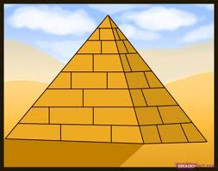
- Glue the rectangle to the map. The picture should stand up.

Extension
If you have the opportunity, mount your map onto a poster. Create small note cards with details about 3 or 4 of the landmarks and glue them onto the poster.

