Landmarks
Jennings

Read me first!!!
What is a landmark?
A landmark includes anything that is easy to recognise, such as a building, mountain or river. The word landmark can also be used to describe places that might be of interest to tourists because of the special parts/features or the role it played in history. Landmarks can also be used to help us give someone directions, for example, “Drive over the large red bridge and then turn left”.
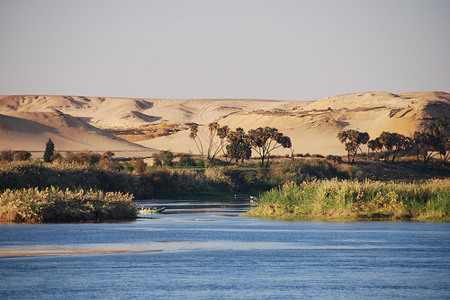
Natural landmark
These landmarks have occurred naturally. These include waterfalls, mountains, rock formations and rivers

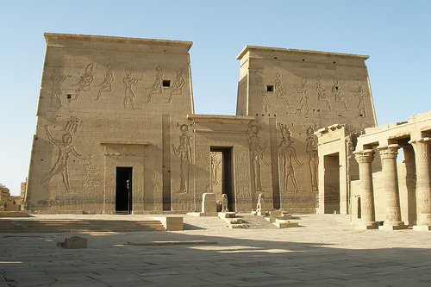
Man-made landmark
These landmarks have been built or created by humans. These include buildings, bridges and statues.

Landmarks Task - Jennings
Your job is to create a 3D map of Ancient Egypt to help us tour around the country in the coming weeks!
You will need:
- The map that you labelled in the Geography Workshop
- Scissors and Glue
- Colour pencils or textas
- Make sure that your map has BOLTSS on it. Remember? Border, Orientation, Legend, Title, Scale and Source

- Read about four of the important landmarks in Ancient Egypt on Landmarks PowerPoint found on the Landmarks page at www.cescancientegypt.weebly.com

- Now it is time to create the 3D (three dimensional) parts of the map.
- Select up to three of the landmarks from Ancient Egypt.

- Using the pictures provided, draw them onto plain white paper and then add a small rectangle at the bottom.

- Cut the picture and the rectangle out. Make a fold at the line between the picture and the rectangle.

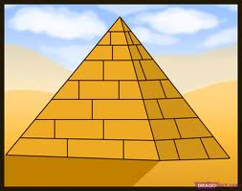
- Glue the rectangle to the map. The picture should stand up.

