**Ancient Egyptian Tools**

**Make a Guess, Check if you’re right!**

Jennings and Rodda

**The answers!!!**

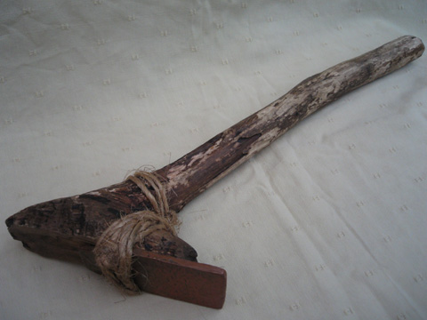1. What tool is that?

a) This tool was used to clip the Egyptians toenails

**C:\Users\02561385\AppData\Local\Microsoft\Windows\Temporary Internet Files\Content.IE5\8D3Q9Q5I\MC910217322[1].wmfb) This tool was used to shape the blocks that were used to build the pyramids. It has metal on the end.**

c) This was a walking stick used in Ancient Egypt

2. What tool is that? (This is a model)

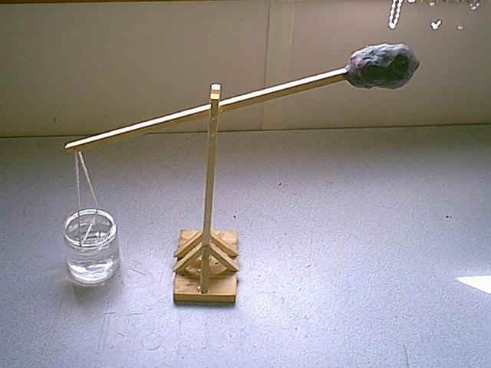

C:\Users\02561385\AppData\Local\Microsoft\Windows\Temporary Internet Files\Content.IE5\8D3Q9Q5I\MC910217322[1].wmf

**a) This is a Shaduf, it was used to get water out of the Nile River for washing, cooking or bathing**

b) This is a flinger, it was used to through rubbish away from the village

c) This is a tool used to punish naughty kids by hitting them on the head with a heavy weight.

3. What tool is that?

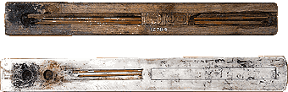

a) Ancient Egyptian style chopsticks

C:\Users\02561385\AppData\Local\Microsoft\Windows\Temporary Internet Files\Content.IE5\8D3Q9Q5I\MC910217322[1].wmf

**b) Writing tools used by scribes in Ancient Egypt, made from reeds**

c) Ashtrays for cigarette butts

4. What tool is that?

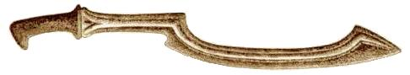a) A tool used in farming to dig the dirt

C:\Users\02561385\AppData\Local\Microsoft\Windows\Temporary Internet Files\Content.IE5\8D3Q9Q5I\MC910217322[1].wmf

**b) A weapon used in wars and ceremonies**

c) A knife used in preparing food and cooking