Jennings and Rodda
Expected Learning:
- To understand the life and role of farmers in Ancient Egypt by analysing a variety of sources.
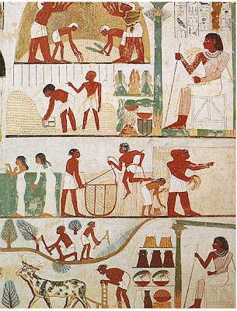
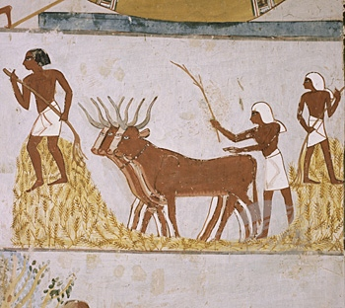
Most ancient Egyptians were farmers, also known as peasants (which means very poor people who depend on the land). Farms were close to the Nile River and the farmers used its water to grow their crops. Farming life was very busy, each day the family had to grind wheat to make bread, collect water to drink and tend to the animals. Only very wealthy families could afford large herds of cattle, most families (except for the very poor) had one to help with farming.

Farmers grew a variety of crops. They grew wheat, lentils, beans, onions, cucumbers, grapes and figs to eat. Wheat and other grains were made into bread or beer. Papyrus was grown to make paper, boats and baskets (it could also be eaten), and flax plants were grown to make linen, which was made into fine clothing. The images you will see below show peasants wearing linen clothing.

Peasants had to give some of their harvest to the government as tax. During the Growing Season tax inspectors visited each farm to collect tax from the farmers (usually about 20% of what they had grown). The grain collected was used to pay other employees of the Pharaoh.
Read the text above and answer the questions in your workbook:
- Who or what are peasants?
- Explain in two sentences how the Nile River influenced the life of farmers.
- Draw a two column table in your book. In one column list the different foods the Egyptians grew and in the other list the other materials grown by farmers.
- Why were the peasants an important part of Egyptian life?
- Make a list of the similarities and differences between Ancient Egyptian farming and farming (or life) in Australia today.
Examine the Primary Source images below and explain in one sentence what farming job the person/s are performing.

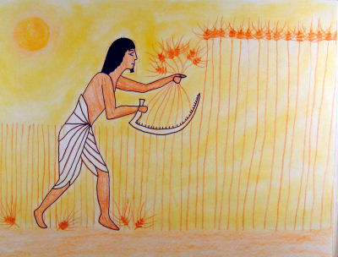
Example: Image 1- The Egyptian farmer is harvesting wheat using a sickle (a sharp tool). Wheat was used to make bread and beer.
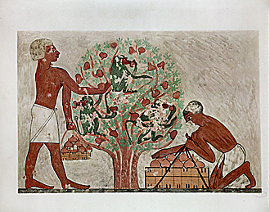

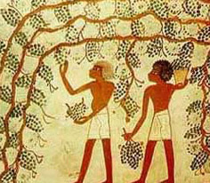
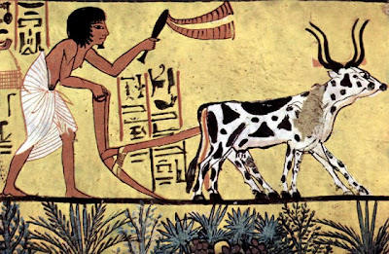
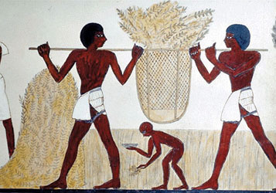
Meyers and Tolkein
Expected Learning:
- To understand the life and role of farmers in Ancient Egypt by analysing a variety of sources.
Most ancient Egyptians were farmers, also known as peasants (which means very poor people who depend on the land). Farms were located close to the Nile and farmers used its water to grow their crops. Farming life was very busy, each day the family had to grind wheat to make bread, collect water to drink and tend to the animals. Only very wealthy families could afford large herds of cattle, most families (except for the very poor) had one to help with farming.

Farmers grew a variety of crops. They grew wheat, lentils, beans, onions, cucumbers, grapes and figs to eat. Wheat and other grains were made into bread or beer. Papyrus was grown to make paper, boats and baskets (it could also be eaten), and flax plants were grown to make linen, which was made into clothing.

Peasants had to give some of their harvest to the government as tax. During the Growing Season tax inspectors visited each farm to collect tax from the farmers (usually about 20% of what they had grown). The grain collected was used to pay other employees of the Pharaoh.
Read the above text and answer the following questions in your workbook.
- Who are peasants and why were they an important part of Ancient Egyptian life?
- Describe the influence the Nile had on the life of farmers (minimum two sentences).
- Make a list of the similarities and differences between Ancient Egyptian farming and farming (or life) in Australia today
- Examine the images on the following page and suggest why there may have been so many Ancient Egyptian paintings of farming and agriculture.

Examine the Primary Source images below and explain in one sentence what farming job the person/s are performing.
Example: Image 1- The Egyptian farmer is harvesting wheat using a sickle (a sharp tool). Wheat was used to make bread and beer.

