Ancient Egyptian Tools
Make a Guess, Check if you’re right!
Jennings and Rodda

- First of all, put your thinking hats on! List as many tools, that are used in Australia today, that you can think of. Write a long list of them.
Think about areas such as building, creating art, making clothes, preparing and cooking food, defending ourselves, etc

- What tool is that?
Look at the images below, these are tools that were used in Ancient Egypt. There are three possible answers provided. You need to think about which of the answers is most likely and select one. You need to write a sentence to explain why you chose that one.
For example:
What is this tool?
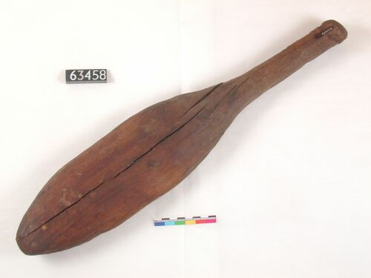
a) A tool used to shape lace up high heel shoes
b) A bat that was used to beat washing clean in the Nile River
c) An Ancient Egyptian fly squatter

Student Answer: I think the answer is B because I don’t think people wore high heels in Ancient Egypt and it seems too bit big to wave around trying to kill a fly.

No cheating!!!

- Check your answers. Open the answers document on the Tools page at www.cescancientegypt.weebly.com to check your answers. Correct your work using the answers provided.

Ancient Egyptian Tools
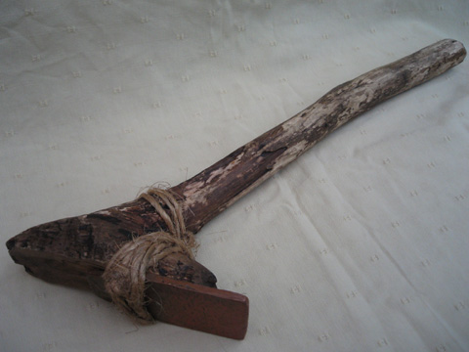
1. What tool is that?

a) This tool was used to clip the Egyptians toenails

b) This tool was used to shape the blocks that were used to build the pyramids. It has metal on the end.

c) This was a walking stick used in Ancient Egypt

2. What tool is that? (This is a model)
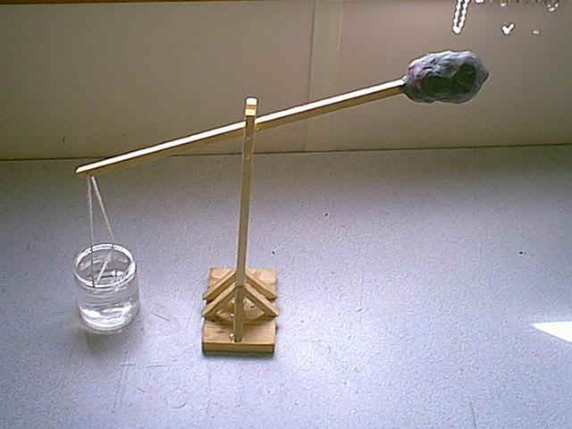

a) This is a Shaduf, it was used to get water out of the Nile River for washing, cooking or bathing

b) This is a flinger, it was used to through rubbish away from the village

c) This is a tool used to punish naughty kids by hitting them on the head with a heavy weight.

3. What tool is that?
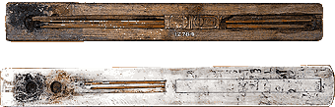
a) Ancient Egyptian style chopsticks

b) Writing tools used by scribes in Ancient Egypt, made from reeds

c) Ashtrays for cigarette butts

4. What tool is that?
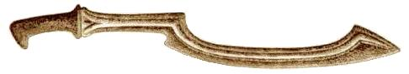
a) A tool used in farming to dig the dirt

b) A weapon used in wars and ceremonies

c) A knife used in preparing food and cooking

