Ancient Egyptian Tools
Meyers and Tolkien
1. Brainstorm a list of at least thirty tools that we use today, in Modern Australia. Tools may fit into categories such as:

- Building and maintenance
- Cooking
- Art and craft
- Cosmetics or beauty
- Gardening and farming
- Self defence

2. Your task is to research one of the tools that Ancient Egyptians used. After reading information about the tool (what it was made of, how it was used, who used it) you are to create a one page ‘Did you know?’ cartoon. Your cartoon is limited by your imagination, but must include at least six facts about your tool. Don’t forget to include diagrams!
Did you know that many of the people that used the ......
Did you know that the ........
Did you know that the ........ was made from

Some Ancient Egyptian tools include:

- Adzes
- Shaduf
- Chisels
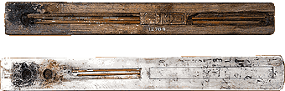
- Flint knife
- Winnowing scoop
- Bow drill
- Reed brushes

