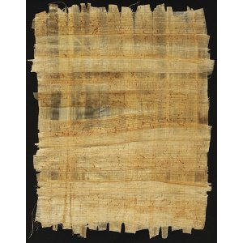
Papyrus – the paper of Ancient Egypt
Jennings
For this task you will need:
- An iPad or a Computer to watch a movie clip
- Scissors and glue

- Borrow a computer or iPad. See if anyone else in Jennings is doing this task and share a computer if you can.

- Open the movie file ‘How Ancient Egyptians made paper’ to watch a short clip a demonstration about how to make paper with papyrus. (see Teacher for the link)

- Your task is to put the steps below into the correct order. You can cut and paste these into the correct order, or rewrite them into your books. You then need to draw at least two of these steps next to the written description.
The reeds are soaked in water for 6-12 days to soak most of the sugar out of them.
The white fleshy part of the papyrus is sliced into thin slices and hit with a hammer to break the strong fibres apart.
After soaking, the papyrus is laid in a criss-cross pattern between two sheets of cotton.
The reed is cut off the plant that grows on the edge of the Nile River.
The papyrus is then rolled flat. Water and some of the sugar leaks out at this point.
The papyrus sheet is then placed under something heavy and left for 6 days.
The green bark is cut away from the outside of the reed. It is very strong and is used to make sandals and baskets.
After 6 days the piece of ‘paper’ has been made because the reeds stick to each other to become one sheet.

