Landmarks
Tolkien
What is a landmark?
A landmark includes anything that is easy to recognise, such as a building, mountain or river. The word landmark can also be used to describe places that might be of interest to tourists because of the special parts/features or the role it played in history. Landmarks can also be used to help us give someone directions, for example, “Drive over the large red bridge and then turn left”.
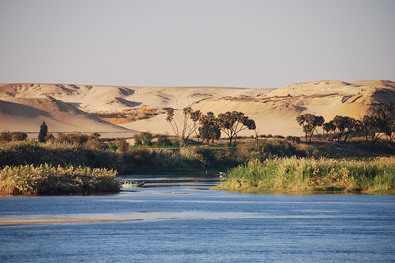
Natural landmark
These landmarks have occurred naturally. These include waterfalls, mountains, rock formations and rivers

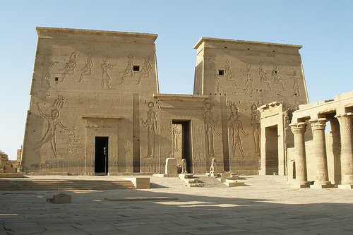
Man-made landmark
These landmarks have been built or created by humans. These include buildings, bridges and statues.

Landmarks Task - Tolkien
You job is to create a detailed of Ancient Egypt to help us tour around the country in the coming weeks!
You will need:
- A map template
- Reference books or iPad/Internet
- Trace the map of Ancient Egypt onto a plain A4 page using the map template provided. Add BOLTSS to your map.

- Using the reference books or Internet research the location of the following landmarks in Ancient Egypt. Mark the landmarks onto your map.
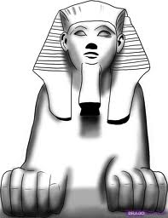

Rivers/Seas
Nile River
Mediterranean Sea
Red Sea

Capital Cities
Memphis
Cairo
Thebes

Pyramids/Sculpture
Pyramids of Giza
Pyramid of Khafre
Great Sphinx

Special Places
City of the Dead
Upper Kingdom
Lower Kingdom
Valley of the Kings
Valley of the Queens

- Select five of the landmarks on the list and research details about these places. Write a paragraph to share this information with the audience.

- Come up with a creative way of adding these paragraphs to your map. Think about getting the audience to ‘interact’ with the map to find this information. (Envelopes, pop ups?)

