A day in the life of a Pharaoh
You are to colour in the Pharaoh below and then write a paragraph (3-5 sentences and you MUST use TEEL) about the life in the day of your Pharaoh. Include information such as:
- the name,
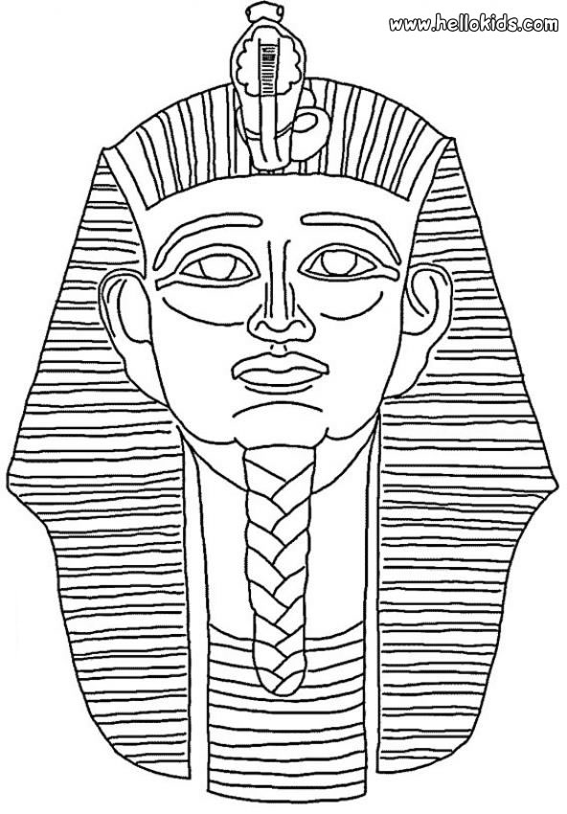
- position in society,
- if the Pharaoh has any children,
- what are the children’s names,
- who is married to who,
- what you ordered your
scribe to do today etc.

